Vulcan Activity Tracker
Weekly Report

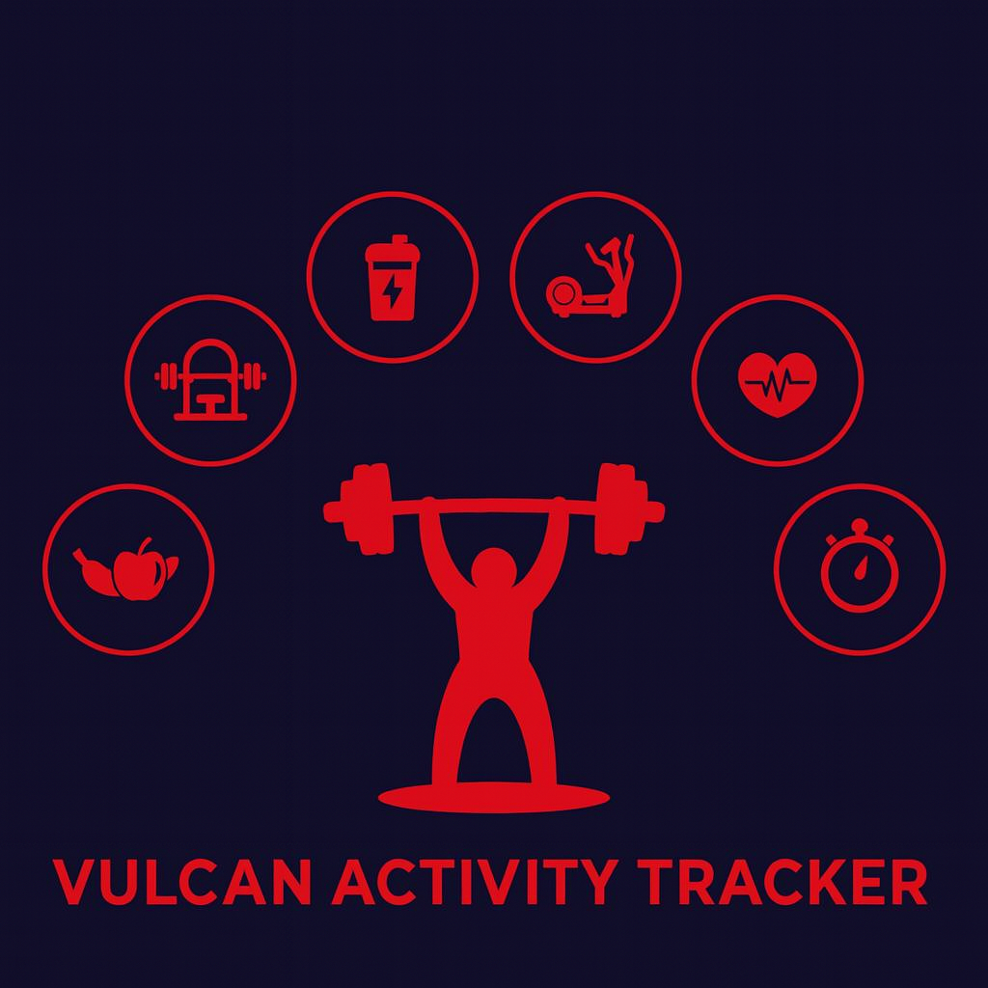

Week 5
Team Members:
Margo Bonal
John Gerega
Luke Ruffing

Professor: Dr. Weifeng Chen

Course: CMSC-4920-Senior Project II
School: Pennsylvania Western University

Table of Contents
Project: Vulcan Activity Tracker 3
Goals Accomplished: 3
Challenges Faced: 4
Solutions: 5
Team Progress: 5
Gantt Chart: 7
Week 6 Plan: 7
Member Contribution: 8

Project: Vulcan Activity Tracker
To complete the proposed goals in previous week’s report, our team followed a strict schedule of daily progress and communication. Our team had 4 main goals to complete, which included fixing the leaderboard page, beginning work on the challenges page, continuing work on the club page, and implementing an ability to view a friend’s profile. Since each goal needed time allocation for development and testing, we assigned each goal priority based on how they were connected to each other. Throughout the discussion, we decided that leaderboard was the main goal to solve as we had hoped to have that done before this week. Achieving this goal can help us get back on track.

Goals Accomplished:
One of the most important goals for this week was completing the leaderboard page. The leaderboard page is designed to extract users’ activities and filter them based on activity type or other general statistics. Work was done to extract sport-specific activities and filter the data based on the number extracted from the database.
The second goal for week 5 was continuing the development of Friends Feature. To implement social interaction between student users of our platform, we needed to allow users to view each other’s activities. Users will only be able to view activities that have been set to public. This enables platform privacy and an opt-in/out system to provide accessibility to all students. If a student wishes to remain private, activities can be set to private upon creation. However, since clubs are designed for group participation in mind, they are public features only and cannot be set to private.
With this week’s development progress, a user can now click on a friend displayed in the friend list and click on the view profile feature. Here, users can see public activities and clubs formatted in the same cohesive design to encourage seamless transition between features. The Friends profile displays as a modal rather than a full page with color fading to bring focus to the pop-up feature. This design component was carefully thought out to ensure that users didn’t feel like they left their page, rather just viewing an extension of their profile.
The final feature added this week was an addition onto the clubs page. Club owners now have the ability to permanently delete their club if they choose to. Additionally, users can now access individual club detail pages which displays the clubs description and member list. These club detail pages will be able to hold more club specific data in the future.

Challenges Faced:
(Number aligns with its solution below)
1. The leaderboard table began extracting sport specific data but would not rank the users correctly. At first, it was ranked based on the users order in the database, so it did not matter what totals each user had.
2. Developing the friend’s feature brought a few styling and logic challenges. Since this feature is a pop-up modal or overlay, it was tricky to get components such as tables, cards and buttons to display on the modal rather than on the dashboard itself as default. Also, in attempt to reuse API components to fill activity and club fields on the modal, we found logic was complex to make sure that the changes did not reflect on the dashboard.
3. Our current route handler function was unable to handle taking dynamic URL parameters. This was a problem because each club detail page needed a unique route identifier in order to load that clubs specific data.

Solutions:
1. Originally, once the leaderboard page was rendered, the rankings would not update the values based on the sport type. So, we had to implement a function that would render the rows based on the sport type. So, in the same way we extracted sport specific data, we sort the table. When a new sport is selected, the database is looked through for that type of activity and totals up any data in an activity that matches the filter applied. This resulted in successful and accurate leaderboard rankings.
2. Styling errors were fixed by ensuring that each modal component had an html id field that differed from the similar dashboard component. For example, when an activity was updated on the dashboard, a separate id was checked to update the friend modal’s activity field. These specific IDs also aided in logic fixes, since we were able to point our API connections to these specific IDs to stop the crossing of data.
3. We fixed this problem by adding a separate dynamic route handler function that accepts the club ID as a parameter. From there it renders a basic club details template, and then the JavaScript pulls the ID from the URL to add the club specific data to the page.

Team Progress:
According to our Group 2 Gantt chart, our team is on schedule for many parts of the tracker, this can be attributed to having more time and less assignments in the early weeks of the semester. However, we are slightly behind schedule on challenge page development due to weekly time constraints. Our team has identified that we need to schedule appropriate time in the upcoming week to make additional progress on our Senior Project to ensure that we leave enough time for debugging and quality checks.
We are still exactly on schedule for dashboard development. During this week our core focus has shifted to finishing the leaderboard and club pages. Significant progress has been made on the finalizing of the leaderboard data filtering. Also, significant progress has been made on the creation of viewing platform friend accounts. Further progress has been made on the club page, including the addition of the view and deleting club buttons. In correspondence with these features, work has been done to create all server side/database implementation to power the app.
With the initial frontend design completed, we were able to focus on developing the next key features of our app, while enhancing existing features. Our team has proposed that in the upcoming weeks development will shift to the creation of the Maps, Teams, and Challenges pages. Each will need allotted significant time for development. While our Senior Project team is still far from reaching our ultimate end goal of The Vulcan Activity Tracker’s end of semester app launch/ presentation, we are building a strong foundation that allows for the platform to grow.

Gantt Chart:
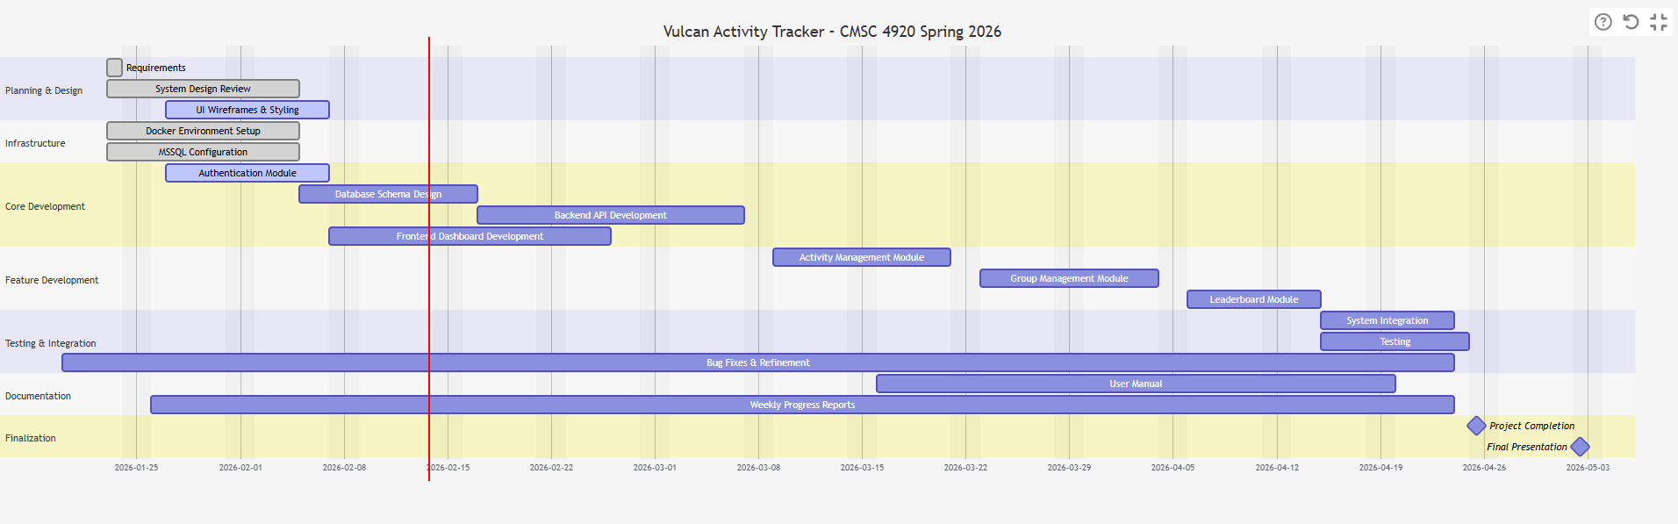

Week 6 Plan:
Durning week 6 our team plans to continue development on the features and pages worked on this week while also starting development on some new features. With the initial design and some of the basic features being completed within the clubs and leaderboard pages, one of this week’s goals is to further expand on that progress. This includes improving data filtering and ranking within the leaderboard page and adding more features to the club page.
In addition to working on existing features the team will begin initial development of some social components of the tracker. This includes planning and maybe perhaps early implementation of group challenges and friend-related features. We propose that week 6 will be a productive week to move our project a step closer to the end goal!

Member Contribution:
Margo Bonal:
- Team meetings, Week 5 Report & Slides, Dashboard page progress, View Friends feature, API creation, Docker performance upgrades
John Gerega:
- Team meetings, Week 5 Report & Slides, Leaderboard page progress
Luke Ruffing:
- Team meeting, Week 5 Report & Slides, Clubs page progress

